**NETWORK TOPOLOGY CREATION USING NS2**

**AIM**

To generate a network topological node (minimum of 5 nodes) with suitable link characteristic using network simulator version 2

**PROCEDURE**

**In test.tcl file**

1. Create a simulator object which is an event scheduler using set ns [new Simulator]
2. Turn on tracing by opening the NAM trace file in writing mode and trace all the packets
3. Define a finish procedure to execute the NAM on the trace file
4. Create 6 topological nodes and assign corresponding variables
5. Create link between node n0 n1, n1 n2, n2 n3, n3 n4, n3 n5 which is a duplex link with queue as RED
6. Set queue limit to node n2 and n3 with 10 count
7. Provide orientation to the nodes linked with each other to be displayed on the NAM trace file
8. Create a TCP agent and attach tcp with the node n0
9. Create a traffic sink and attach sink with node n5

10 Then connect both the agents , tcp and the traffic sink

11. Set up a CBR over a TCP Connection by attaching cbr with tcp

12. Schedule events for CBR agent to start and stop

13. Call the finish procedure after 5 seconds of simulation time

14. Print CBR packet size and interval on the terminal

15. Finally run the network simulator using the command $ns run

**SOURCE CODE**

set ns [new Simulator]

set nf [open out.nam w]

$ns namtrace-all $nf

proc finish {​​​​​​}​​​​​​ {​​​​​​

global ns nf

$ns flush-trace

close $nf

exec nam out.nam &

exit 0

}​​​​​​

set n0 [$ns node]

set n1 [$ns node]

set n2 [$ns node]

set n3 [$ns node]

set n4 [$ns node]

set n5 [$ns node]

$ns duplex-link $n0 $n1 1Mb 10ms RED

$ns duplex-link $n1 $n2 1Mb 20ms RED

$ns duplex-link $n2 $n3 1Mb 10ms RED

$ns duplex-link $n3 $n4 1Mb 20ms RED

$ns duplex-link $n3 $n5 1Mb 10ms RED

$ns queue-limit $n2 $n3 10

$ns duplex-link-op $n0 $n1 orient right-up

$ns duplex-link-op $n1 $n2 orient right-down

$ns duplex-link-op $n2 $n3 orient right

$ns duplex-link-op $n3 $n4 orient left-up

$ns duplex-link-op $n3 $n5 orient left-down

set tcp [new Agent/TCP]

$ns attach-agent $n0 $tcp

set sink [new Agent/TCPSink]

$ns attach-agent $n5 $sink

$ns connect $tcp $sink

set cbr [new Application/Traffic/CBR]

$cbr attach-agent $tcp

$cbr set type_ CBR

$cbr set packet_size_ 1000

$cbr set rate_ 1mb

$cbr set random_ false

$ns at 0.1 "$cbr start"

$ns at 4.5 "$cbr stop"

$ns at 5.0 "finish"

puts "CBR packet size = [$cbr set packet_size_]"

puts "CBR interval = [$cbr set interval_]"

$ns run

**OUTPUT SCREENSHOT**

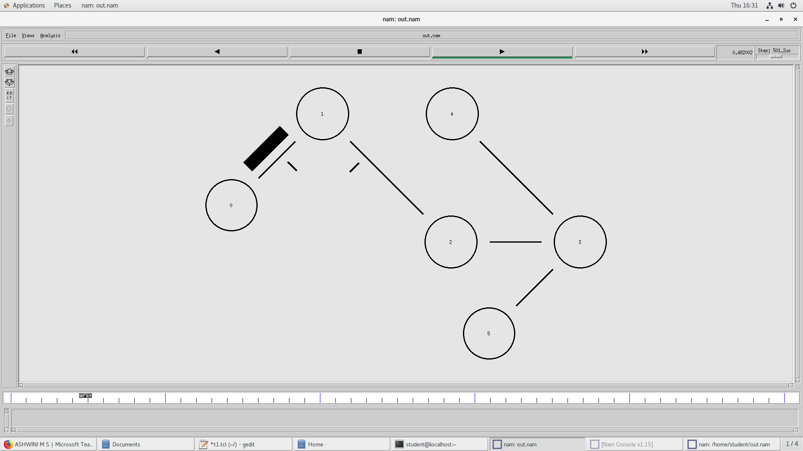

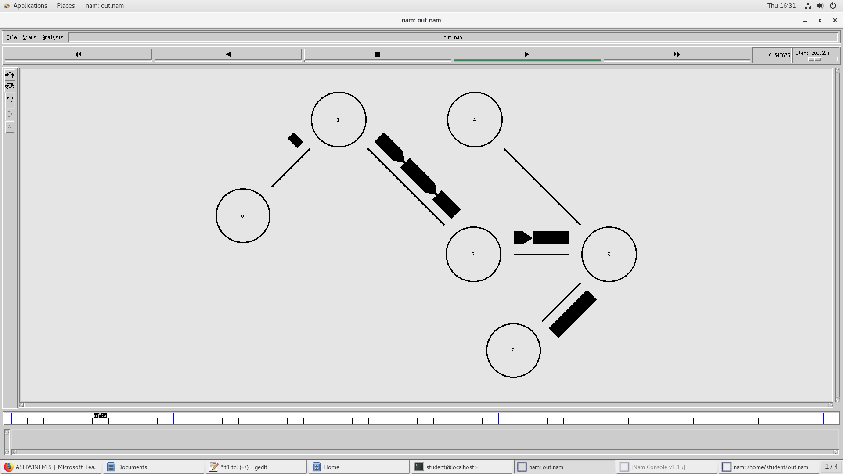

**RESULT**

Hence a network topological node with suitable link has been created using ns2